**Disciplined Entrepreneurship Workbook**

# Step 13: Map the Process to Acquire a Paying Customer

|  |
| --- |
|  |

## Worksheets

|  |  |  |  |  |  |  |  |  |  |  |
| --- | --- | --- | --- | --- | --- | --- | --- | --- | --- | --- |
| Process to Acquire a Paying Customer | | | | | | | | | | |
| **Stage #** | **1** | **2** | **3** | **4** | **5** | **6** | **7** | **8** | **9** | **10** |
| General Description of Stage | ***Determine Need & Catalyst to Action*** | ***Find Out about Options*** | ***Analyze Options*** | ***Acquire Your Product*** | ***Pay*** | ***Install*** | ***Use & Get Value*** | ***Determine Value*** | ***Buy More*** | ***Tell Others*** |
| What does the customer do in this stage? (from the Full Life Cycle Use Case) | **Realizes need for better travel planning / unique experiences due to time constraints or lack of quality content** | **Searches Reddit, forums, influencers, or friends for alternatives** | **Compares features, value, and price of your platform vs. competitors** | **Signs up for a free trial or basic package** | **Chooses a plan and enters payment details** | **Downloads app (if mobile) or begins using the web interface** | **Uses platform to plan trip, books experiences or lodging** | **Reflects on how useful it was compared to cost/time saved** | **Upgrades, adds more services (like group trips or premium concierge)** | **Leaves reviews, refers friends, shares on social media** |
| Who is involved from the DMU? | |  | | --- | | **End User** |  |  | | --- | |  | | **End User, Champion** | **End User, Economic Buyer** | **Champion, Economic Buyer** | **Economic Buyer** | **End User** | **End User** | **End User, Economic Buyer** | **Economic Buyer, Champion** | **End User** |
| Budget limits & other con-siderations | **No purchase yet, just internal need** | **Comparing multiple options (free and paid)** | **May hesitate due to subscription costs** | **May require approval for paid features (esp. in B2B)** | **Subscription budget or expense approval** | **None** | **May start comparing real experience to expectations** | **Value perception vs. cost** | **Cross-sell budget or personal motivation** | **None** |
| How much time will this stage take? (give a range) | **1–3 days** | **2-5 days** | **3–7 days** | **1 day** | **1 day** | **Less than 1 day** | **3–10 days** | **2–5 days** | **2–4 days** | **1–3 days** |
| Action plan to accomplish stage | **Social media hooks, relatable content** | **SEO, content marketing, influencer collabs** | **Landing pages with demos, reviews, and testimonials** | **Onboarding via email or UX flow** | **Limited-time offers, trial-to-paid nudge** | **Clear installation/setup instructions** | **In-app suggestions, AI support** | **Feedback survey, reward incentives** | **Smart upsells, loyalty perks** | **Referral program, incentives** |
| Risks | **They don’t realize they have a need** | **Competitors show up first** | **Competitor undercuts price** | **Drop-off during signup** | **Abandon cart** | **Tech issues** | **Confusion about features** | **Negative reviews** | **Lack of perceived value** | **No incentive to share** |
| Risk mitigation strategy | **Educational storytelling content** | **Targeted SEO, strong branding** | **Highlight unique value** | **Smooth onboarding** | **Reminder emails, urgency triggers** | **24/7 support, FAQs** | **Tooltips, guided flow** | **Proactive outreach** | **Personalization of offers** | **Easy share and rewards** |
| Misc. | **May be triggered by failed past trip, upcoming travel plans, or peer influence** | **Strong opinions on Reddit/forums can sway perception early** | **Users may consult multiple friends or influencers for validation** | **Clear CTAs and value messages improve trial signups** | **Some customers may seek promo codes or corporate discounts** | **Ensure cross-device compatibility (web, iOS, Android)** | **Gamification elements may boost early engagement** | **Customers may post on social media without prompting** | **Upsell opportunities stronger if trust is built in first use** | **Enable one-click social sharing and referral link creation** |

### Convert to a First Draft Sales Cycle Length Analysis Summary

**Sales Cycle Length Estimate**

For all time estimates except for lead generation, use the numbers from your Process to Acquire a Paying Customer table above. Make a reasonable estimate for lead generation.

|  |  |  |
| --- | --- | --- |
| Sales Funnel Element | Full Life Cycle Use Case Stage | Estimated Time to Complete |
| **#1 – Identification:** Lead Generation  ***Output: Leads*** | n/a | **3–5 days** |
| **#2 – Consideration:** Create Awareness to Potential Customers  ***Output: Suspects*** | ***#1 - Determine Need & Catalyst to Action***  ***&***  ***#2 - Find Out about Options*** | **3–8 days** |
| **#3 – Engagement:** Develop Initial Dialogue  Output: Prospects  &  **# 4 – Purchase Intent:** Develop Interest to Intent  ***Output: Qualified Prospects*** | ***#3 - Analyze Options*** | **3–7 days** |
| **#5 – Purchase:** Close Deal & Pay  ***Output: Customers*** | ***#4 - Acquire Your Product***  ***&***  **#5 – Purchase:** Close Deal & Pay  ***Output: Customers*** | **1–2 days** |
| ***Total time for sales cycle:*** | | **10–17 days** |

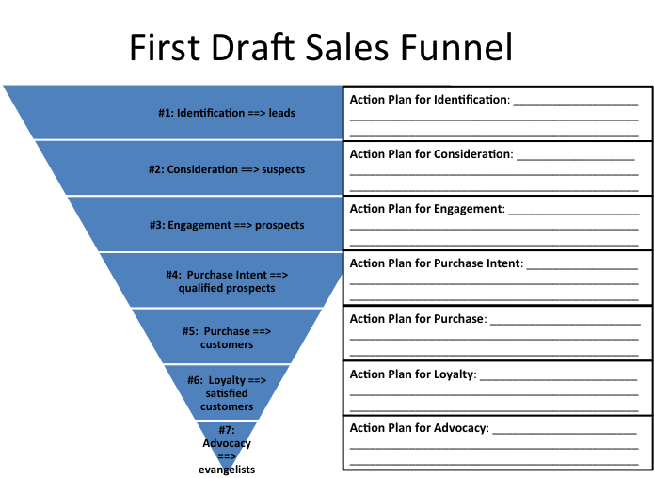

**#1: Action Plan for Identification:**

* **Leverage SEO-optimized travel blog content, social media (Instagram, TikTok, Reddit), and targeted ads to attract niche travel enthusiasts.**
* **Engage in online communities and watering holes like travel subreddits and Facebook groups.**

**#2: Action Plan for Consideration:**

* **Deploy email drip campaigns, comparison content (why us vs. others), and influencer testimonials.**
* **Highlight pain points (wasted planning time, uncertainty) and how your platform solves them.**

**#3: Action Plan for Engagement:**

* **Offer free trials or a limited preview of curated travel plans.**
* **Host webinars or live Q&A sessions to build trust and answer questions directly.**

**#4: Action Plan for Purchase Intent:**

* **Provide clear pricing, a frictionless sign-up flow, and urgent offers (discounts, limited spots).**
* **Use behavioral triggers like “you left something in your cart” to nudge signups.**

**#5: Action Plan for Purchase:**

* **Offer easy checkout and a welcome experience that confirms their decision.**
* **Use a friendly onboarding walkthrough to ensure immediate perceived value.**

**#6: Action Plan for Loyalty:**

* **Provide personalized trip suggestions, loyalty rewards, and early access to premium features.**
* **Keep in touch with tailored emails based on past behavior or saved preferences.**

**#7: Action Plan for Advocacy:**

* **Launch a referral program and showcase customer stories on social media.**
* **Encourage reviews/testimonials and reward users for sharing your platform publicly.**

**Qualitative Summary:** ***How would you qualitatively summarize the Process to Acquire a Paying Customer in three sentences or less?***

**The process to acquire a paying customer starts by attracting travel enthusiasts through social media, SEO, and community engagement. From there, users evaluate and engage with the platform via demos, free trials, and testimonials, which build trust and move them toward purchase. After buying, a seamless onboarding and continued personalized value help drive satisfaction, loyalty, and advocacy.**

***Which areas of this process are you comfortable that you have mapped out well?***

1. **Lead generation and customer awareness through strong content and community presence.**
2. **Purchase and onboarding experience with a streamlined flow and immediate value delivery.**
3. **Post-purchase loyalty strategies like tailored recommendations and rewards programs.**

***Which areas of this process are you concerned about that you will want to keep an eye on as you proceed?***

1. **The conversion of engaged users into paying customers (purchase intent to purchase) and drop-off risk at that stage.**
2. **Maintaining consistent value delivery at scale to support loyalty and advocacy without diluting the quality of personalized experiences.**
3. **Budget limitations and approval timelines for some customer segments, particularly in group or family travel.**